Matthew Boler

ELEC 7450 – Image Processing

Exercise 1

Images can be read and displayed through the **imread** and **image** functions. The **imread** function can return both a matrix of image data and a colormap matrix, which maps the integers [1, 255] to (R, G, B) tuples. For example, the following snippet: **[X, map] = imread(‘sedona.png’); image(X); colormap(map)** produces the first attached image. By switching the colormap to **gray(256)**, the data in the image matrix is treated as literal gray values rather than indices referring to (R, G, B) combinations. This results in the second, nonsensical image. In this colormap, increasing indices indicate increasing lightness. A ramp image can be generated via: **x = 0:255; ramp_img = repmat(x, 256, 1); image(ramp_img); colormap(gray(256))** wherein the brightness of the image increases with left to right motion. This is shown in the third attached image. We can also create tinted images by modifying the colormap. Converting our indexed image to a gray image via **img_gray = ind2gray(X, map)** makes our pixel values intensities on [0, 256]. Converting back to an index image via **img_ind = gray2ind(img_gray, 256)** now lets us use the parula colormap, shown in the fourth attached image. Alternatively, converting **img_ind** to an rgb image via **I = ind2rgb(img_ind, parula)** lets us save it via **imwrite(‘sedona_parula.png’)**.

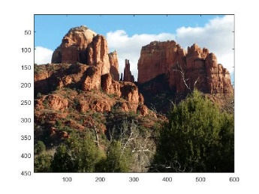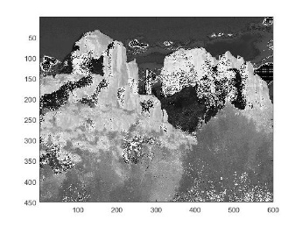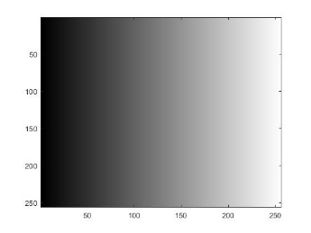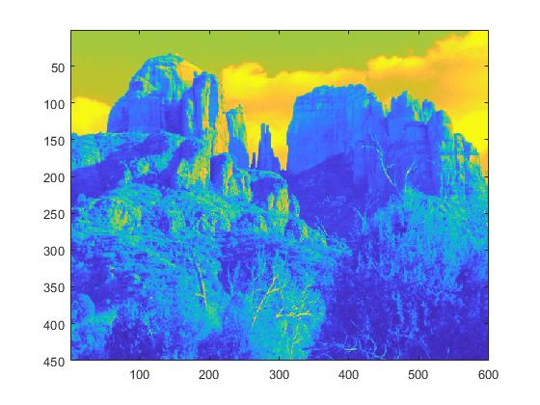

Here we have two images of the same piece of paper, taken seconds apart without moving the sheet:

 

Despite appearing to be homogeneously white in the real world, these images are mottled (though generally in the near-white range of grayscale, with intensities above 200). This is somewhat surprising, though what is more surprising is that they are different images entirely, as subtracting them does not give us the zero matrix. This can be attributed to a variety of noise characteristics of the sensor, but the differences themselves are hard to characterize other than they look like ‘normal’ image noise.